**How to clone git remote repository into local system**

Step 1: Open a drive where you want to clone the repository say D: drive.

Step 2: Open command line to that location

Step 3: Issue a command “git clone <remote repo path>”

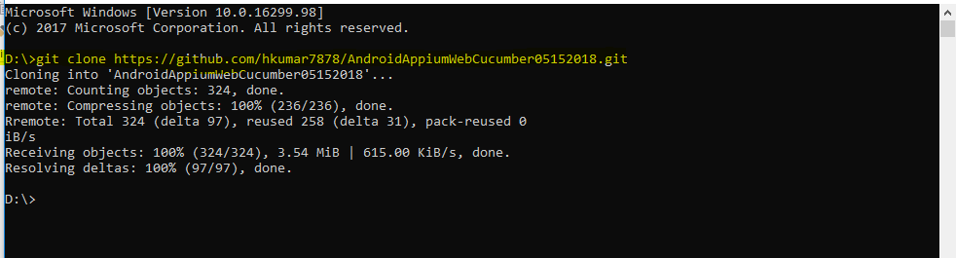

Step 4: Check that clone repo in D drive.

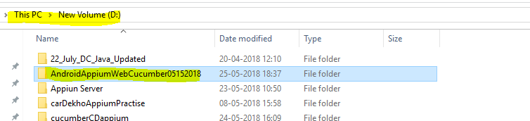

Note: Cloned repository can be cloned with different name by using the following command

